CIDM 6341-01 Current issues in Cybersecurity

Mariam Adegbindin

**Question 1: What did you do?**

Refog (Hover watch)

I installed Hover watch which is a key stroke monitoring app for Mac OS. Navigating the website was a bit tricky and I was second guessing the whole process to download it and what amount of permission to give it access to my laptop. After downloading it I had issues with opening it as expected. I then checked my firewall and found out it was never on which I found kind of strange. But then again, I guess I have been using my Wi-Fi (router) firewall and my laptop firewall was not on. I then went into my “Privacy & Security” settings and gave it permission to open the app anyways. I gave the application full permission to monitor my screen content as well as screen shots and my keystrokes when sending messages.

Prey

I had a bit of difficulty signing up for an account. The link opened on my Safari to sign up but for some reason when I used my yahoo mail and school email it wasn’t going through. I then had to try on chrome with my Gmail account and then I was able to sign up. Not sure if it’s an email thing or browser but my guess is it would be the browser. I signed up on my laptop and then linked my iPhone to it by scanning the QR code.

**Question 2: What were the results?**

Refog (Hover watch)

On the website it says to wait 6 mins to see any results. Also, there is a red dot on the top of the screen to indicate that my system is being monitored so I am aware that it is running in the background.

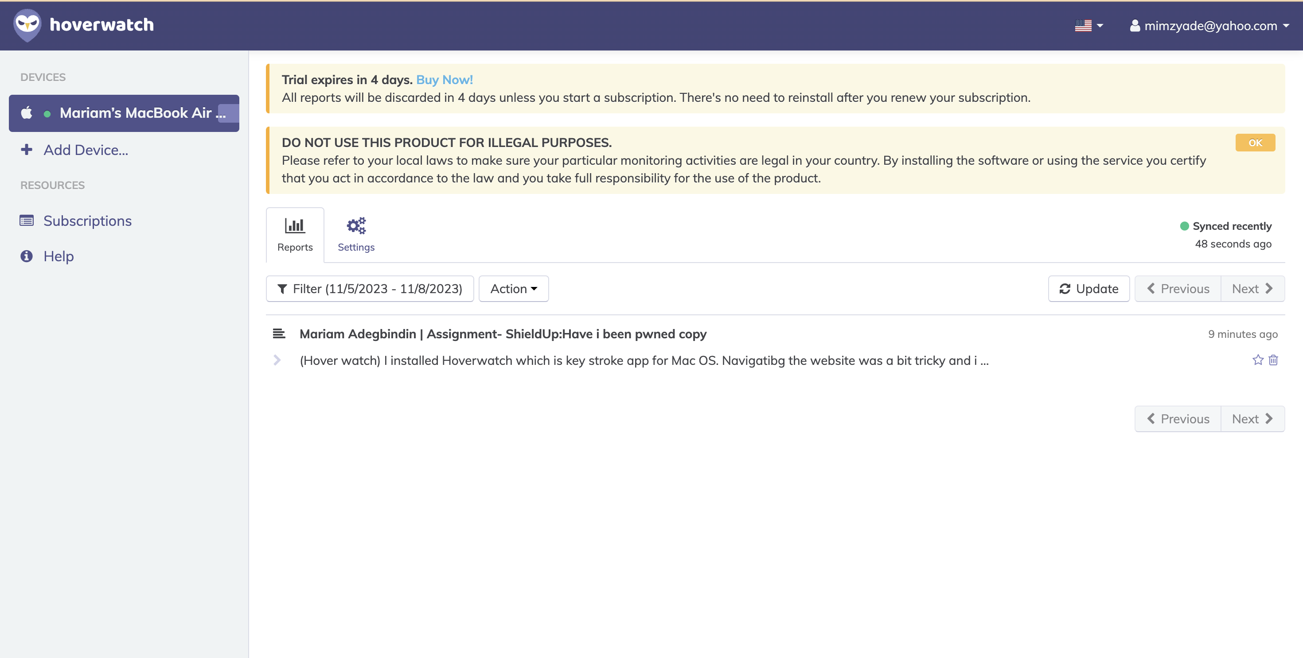

I can see that it is storing my keystrokes as I type this report and it even takes note of the old content in this file which I did not type and mistakes as I type like incorrectly typing a symbol.

It can tell the application I open and perfectly duplicates every keystroke I press.

Prey

I can see the location of my phone and actions I can take such as reporting it missing, sending out an alarm to help find it and sending out an alert message.

I put my phone in my friend’s room, we stay in the same block and same floor but different apartments. I was able to get the approximate location while the phone was still with me but when I try to update the location, I am not able to

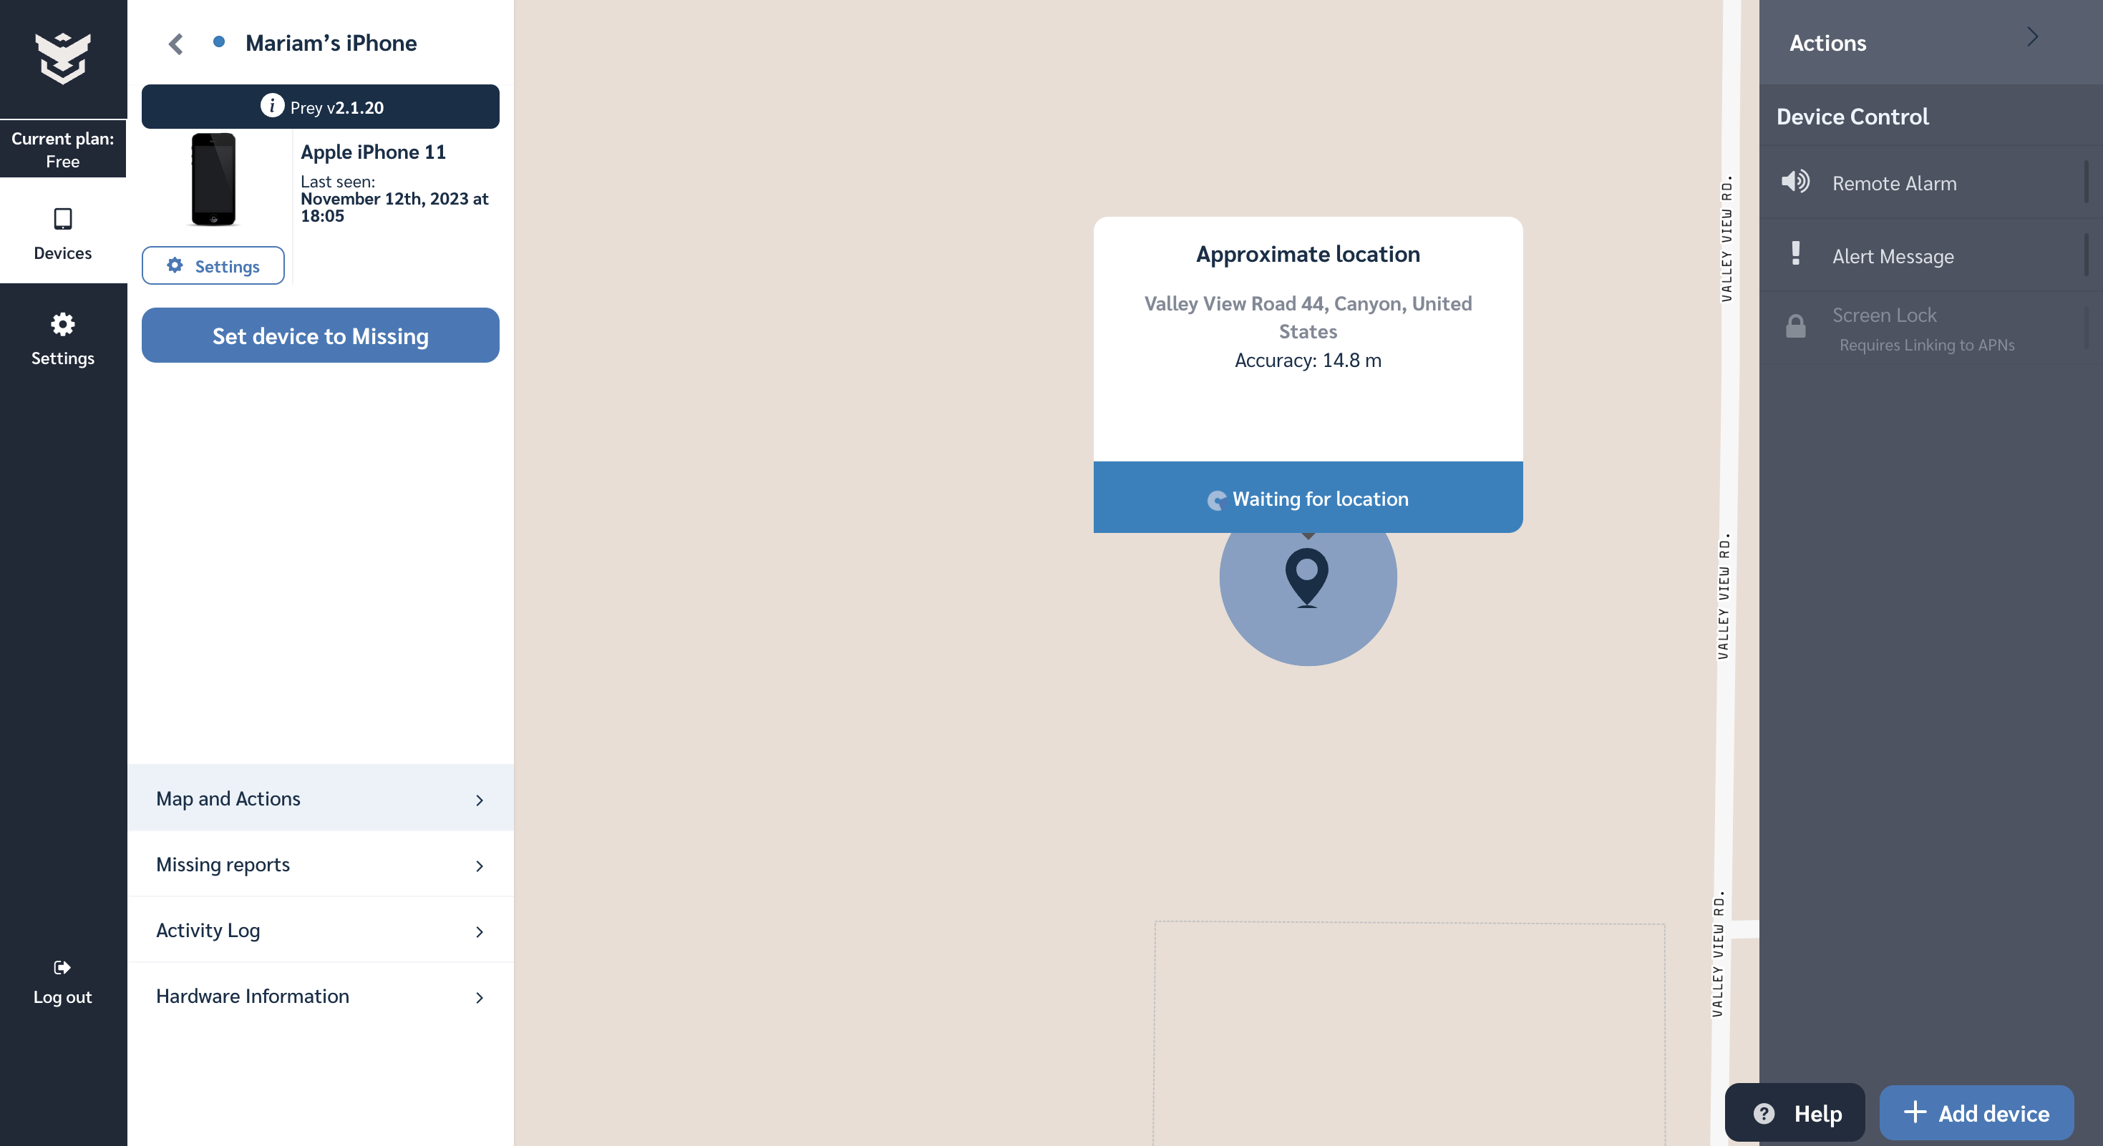

*Approximate location while the phone is in my possession.*

*The location is not able to update after putting the phone somewhere else*

Also, I tried sending out a remote alarm to the phone, but it was not immediately affected. It gave the message “Actions will run when your device reconnects to Preys servers”.

*The device not being able to send out the alarm immediately.*

**Question 3: What did you learn?**

Refog (Hover watch)

It is interesting and scary that Refog can perfectly copy every keystroke I type. I learnt while trying to download the application and set it up that my firewall was never on which is funny seeing as I have been taking a Cybersecurity class this semester and should know better. It takes note of the websites I visit seeing as I am typing into the search bar that makes sense.

*Refog recording my keystrokes.*

Overall, I would say that Refog is 10/10 and works perfectly which is scary and interesting at the same time. One of the advantages of this as I saw on the website is that it helps parents monitor the activities of their kids when they have their own device which is understandable, and I learnt from class that some companies have this type of software’s installed on the company’s systems to monitor employee’s activities.

# Prey

After going to get my phone to figure out why it wasn’t tracking the phone. My conclusion was already that it only works when using the phone. I got my friend to use access my phone and just basically play around with it, but I still got no alarm or alerts that had been sent out. She then had to open the app before the actions that had been initiated was triggered.

*Prey capturing the image and info of the missing phone.*

The last task I tried was declaring my phone missing which worked well and was able to capture details of the location of the phone as well as the person with the phone. I found out that the reason that I thought it was not working properly was because I did not set my permissions correctly to always allow my phone to use my location even when I am not using the app. After I corrected that the other features worked perfectly. The alarm and alert messages came through immediately and the location of my phone was getting updated. Prey is one app I would spend my money on, I would say its top notch and easy to use.